A Report on Mini Project
ACCIDENT PREVENTION IN HILLY AREAS USING IR SENSORS

Submitted for the partial fulfilment of the academic
requirements for the
Award of the Degree of

BACHELOR OF TECHNOLOGY
IN
ELECTRONICS AND COMMUNICATION ENGINEERING

Submitted By
A.MEENAKSHI | 23911A0404
K.E.PRAHARSHITHA | 23911A0431
K.SAI CHARAN REDDY | 23911A0436
P.SAI PRASANNA | 23911A0450

Under the Esteemed Guidance of
Ms. A .JAYA LAKSHMI
Assistant Professor


Department of Electronics and Communication Engineering
VIDYA JYOTHI INSTITUTE OF TECHNOLOGY
(An Autonomous Institute)
(Accredited by NAAC & NBA, Approved By A.I.C.T.E., New Delhi, Permanently Affiliated to JNTU, Hyderabad
Aziz Nagar, C.B.Post, Hyderabad -500075)
2026


(Accredited by NAAC, Approved by AICTE New Delhi & Permanently Affiliated to JNTUH)
Aziz Nagar Gate, C.B. Post, Hyderabad-500 075
Department of Electronics and Communication Engineering
(Accredited by NBA)

CERTIFICATE
This is to certify that the project report titled “Accident Prevention in Hilly Areas Using IR Sensors “is being submitted by A. Meenakshi (23911A0404), K.E. Praharshitha (23911A0431), K. Sai Charan Reddy (23911A0436), and P. Sai Prasanna(23911A0450) of III B. Tech II Semester, Department of Electronics and Communication Engineering, as a record of Bonafide work carried out by them. The results presented in this report are original and have not been submitted to any other University or institution for the award of any degree or diploma.

INTERNAL GUIDE | HEAD OF THE DEPARTMENT
Mrs. A . Jaya Lakshmi | DR. P. Nageshwara Rao
Assistant Professor | Professor
Department of ECE | Department of ECE

EXTERNAL EXAMINER

DECLARATION
We hereby declare that the project work entitled “ACCIDENT PREVENTION IN HILLY AREAS USING IR SENSORS ” is a genuine and original piece of work carried out by us in the Department of Electronics and Communication Engineering, Vidya Jyothi Institute of Technology, under the affiliation of Jawaharlal Nehru Technological University, Hyderabad. This report is the outcome of our own efforts and research conducted during the course of the project. We affirm that it has not been copied, reproduced, or submitted elsewhere for any academic or professional purpose. All sources of information and assistance have been duly acknowledged.

PROJECT ASSOCIATES
Ms. A. Meenakshi | 23911A0404
Ms. K.E.Praharshitha | 23911A0431
Mr. K.Sai Charan Reddy | 23911A0436
Ms. P.Sai Prasanna | 23911A0450

ACKNOWLEDGEMENT
We would like to express our sincere gratitude to our project guide Ms. A .JAYA LAKSHMI MTech., Ph.D., Assistant Professor, for the exceptional guidance, support, and encouragement provided at every phase of this project.

We are deeply thankful to Dr. S. Pradeep Kumar Reddy, B.E., M.Tech., Ph.D., Associate Professor and Project Coordinator, Department of ECE, for his timely and insightful guidance that greatly contributed to the successful completion of our work.
Our sincere thanks also go to Dr. P. Nageshwara Rao, M.Tech, Ph.D., Professor and Head, Department of ECE, for his consistent support and constructive feedback during the course of our study.
We extend our heartfelt gratitude to Dr. A. Srujana, M.Tech., Ph.D., Principal, Vidya Jyothi Institute of Technology, for her motivation and encouragement in the successful completion of our project.
Finally, we express our sincere appreciation to the faculty and staff of the Electronics and Communication Engineering Department, Vidya Jyothi Institute of Technology, for their help and cooperation throughout the duration of the project.

Ms. A.Meenakshi | 23911A0404
Ms.K.E.Praharshitha | 23911A0431
Mr. K.Sai Charan Reddy | 23911A0436
Ms.P. Sai Prasanna | 23911A0450

ABSTRACT
Road accidents in hilly areas are a major concern due to sharp curves, narrow roads, poor visibility, fog, and steep slopes. Many accidents occur because drivers are unaware of vehicles approaching from the opposite direction at blind turns. This project proposes an accident prevention system for hilly areas using IR sensors and a microcontroller to enhance road safety.
The system uses Infrared (IR) sensors installed on both sides of a curved or blind road to detect the presence of vehicles. When a vehicle is detected by the IR sensor on one side, a signal is sent to the Arduino-based control unit, which activates warning indicators such as LED traffic lights and a buzzer on the opposite side of the curve. This alert approaching drivers to slow down and drive cautiously.
Once the vehicle passes, the system automatically turns OFF the warning indicators. This low-cost and energy-efficient system helps reduce head-on collisions and improves driver awareness in dangerous hilly regions. The proposed model is simple, reliable, and suitable for real-time implementation on mountain roads, hairpin bends, and narrow pathways

TABLE OF CONTENTS
CHAPTER | TITLE | PAGE NO
 | ABSTRACT | vi
 | TABLE OF CONTENTS | v
 | LIST OF FIGURES | vi
 | LIST OF TABLES | vii
1 | INTRODUCTION | 1
 | 1.1 Problem Statement | 3
 | 1.2 Objectives  1.3 Literature Survey | 4  5
2 | EXISTING METHODOLOGY | 6
 | 2.1 Limitations of Existing System | 7
3 | PROPOSED METHOLOGY | 8
 | 3.1 Features of Proposed System | 9
 | 3.2 Advantages of Proposed System | 10
4 | SYSTEM DESIGN | 11
 | 4.1 Software Requirements | 12
 | 4.2 Hardware Requirements | 13
 | 4.3 Components used in Proposed System | 15
 | 4.4.1 Arduino IDE | 16
 | 4.4.2 IR SENSOR | 18
 | 4.4.3LCD Display | 19
 | 4.4.4 LED Signal | 21
5 | 4.4.5 Buzzer  SYSTEM ARCHITECTURE  5.1 Block Diagram  5.2 Circuit Diagram | 22  25  26  27
6 | METHODOLOGY | 29
7 | IMPLEMENTATION | 31
 | 7.1 Source Code | 34
8 | RESULTS | 38
9 | CONCLUSIONS AND FUTURE SCOPE  SUSTAINABLE DEVELOPMENT GOALS | 39
 | REFERENCES | 40

LIST OF FIGURES
FIGURE NO | TITLE | PAGE NO
4.4.1 | Arduino IDE | 17
4.4.2 | IR Sensor | 19
4.4.3 | LCD Display | 20
4.4.4 | LED signals | 21
4.4.5 | Buzzer | 23
5.1 | Block Diagram | 25
5.2 | Circuit Diagram | 26
6.1  7.1 | Flow Chart  System Overview | 30  33

LIST OF TABLES
TABLE NO | TITLE | PAGE NO
7.1 | Test Results of Accident prevention in hilly areas using IR Sensors | 37

CHAPTER-I
INTRODUCTION
Background and Importance
Hilly terrains present unique challenges because of steep slopes, limited sight distance, frequent fog, rain, and landslides. Traditional safety measures like road signs, speed breakers, and guardrails often prove insufficient as they do not provide real-time information about hidden oncoming traffic. In India, states such as Himachal Pradesh, Uttarakhand, and Jammu & Kashmir experience a very high rate of road accidents, resulting in thousands of deaths and injuries every year, especially on ghat sections and mountain roads.
The use of IR sensors makes this system highly reliable even in harsh weather conditions like fog, dust, or darkness, where camera-based systems may fail. Relays act as robust switches to control the warning signals efficiently and safely.
Implementing this IR sensor and relay-based system is very important for improving road safety in hilly areas. It is cost-effective, scalable, and supports national road safety goals by addressing accident hotspots. Widespread deployment on tourist circuits, national highways, and dangerous mountain sections can help save many lives and reduce the socio-economic burden of road crashes, making travel safer in challenging terrains.
Objectives and Purpose
The main purpose of the “Accident Prevention in Hilly Areas Using IR Sensors and Relays” system is to enhance road safety on dangerous mountain roads by providing real-time warnings to drivers about oncoming vehicles or obstacles in blind spots. It aims to reduce the high number of accidents caused by poor visibility, sharp curves, and limited sight distance commonly found in hilly terrains. By detecting vehicles early and alerting drivers through visual and audible signals, the system helps prevent head-on collisions, rear-end crashes, and sudden overtaking accidents.

The primary objectives of this project are:
- To design and implement an automated system using IR sensors for reliable vehicle detection even in fog, rain, or low-light conditions.
- To use relays for activating warning devices such as LED lights and buzzers on both sides of blind curves and hairpin bends.
- To provide instant alerts to drivers approaching from opposite directions, giving them sufficient time to slow down or stop.
- To develop a low-cost, microcontroller-based solution that is easy to install and maintain in remote hilly areas without requiring complex infrastructure.
Components Used and System Overview
The Accident Prevention in Hilly Areas Using IR Sensors and Relays is a simple, low-cost, and effective system designed for mountain roads. It mainly consists of basic electronic components that work together to detect vehicles and provide timely warnings at blind curves.
The main components used in the system are:
- Infrared (IR) sensors – for detecting oncoming vehicles even in fog or low light.
- Electromagnetic relays – to safely control the warning devices.
- LEDs and buzzers – to give visual and audible alerts to drivers.
- Microcontroller (Arduino Uno) – as the central processing unit.
- Power supply unit and connecting wires – for reliable operation.
The system overview is straightforward. IR sensors are placed on both sides of sharp curves or hairpin bends. When a vehicle is detected, the microcontroller activates the relays, which turn on LEDs and buzzers from both directions. This gives instant alerts to drivers, helping them slow down or stop and avoid accidents. The setup is microcontroller-based, weather-resistant, and easy to install in remote hilly areas.

Significance and Applications
The Accident Prevention system using IR Sensors and Relays plays a vital role in improving road safety in hilly areas. It provides timely warnings at blind curves and helps reduce accidents where traditional methods fall short. Key significance and applications are:
- Improved Safety: Reduces head-on collisions on sharp bends and hairpin turns by giving early alerts to drivers.
- Low-Cost Solution: Affordable and easy to install using simple components, suitable for remote hilly roads.
- Reliable in Bad Weather: Works effectively in fog, rain, and low light conditions.
- National Importance: Supports road safety goals in high-accident states like Himachal Pradesh and Uttarakhand.
- Wide Applications: Can be used on tourist routes, ghat sections, and busy mountain highways.
1.1 PROBLEM STATEMENT
Road accidents in hilly and mountainous regions have become a serious and growing concern across many parts of India. These areas are naturally challenging for transportation because of their sharp curves, blind bends, hairpin turns, narrow roads, and steep gradients. Drivers frequently encounter sudden oncoming vehicles without any prior indication, which often results in dangerous head-on collisions, rear-end crashes, and loss of vehicle control.
Poor visibility remains one of the major causes of accidents in hilly areas. Due to limited sight distance around curves and frequent changes in road alignment, drivers are unable to see approaching traffic from the opposite direction until it is too late. This problem becomes even more severe during adverse weather conditions such as dense fog, heavy rainfall, dust storms, or low-light situations at night.
Traditional road safety measures like warning signs, speed breakers, reflectors, and guardrails have proven to be inadequate in such environments. These static solutions do not provide real-time information about hidden vehicles or obstacles.
The situation is particularly alarming in Himalayan states such as Himachal Pradesh, Uttarakhand, and Jammu & Kashmir. These regions witness thousands of road accidents every year, leading to hundreds of deaths and serious injuries.
There is a clear and urgent need for an automated, intelligent system that can detect vehicles in blind zones and provide instant alerts to drivers from both directions.
1.2 OBJECTIVES
The main purpose of the “Accident Prevention in Hilly Areas Using IR Sensors and Relays” project is to develop a simple, low-cost, and automated system that can significantly reduce road accidents on dangerous mountain roads. It aims to provide real-time warnings to drivers at blind curves, hairpin bends, and low-visibility zones where traditional safety measures often fail.
Key objectives of the project are:
- To design an automated vehicle detection system using IR sensors that works reliably in fog, rain, and low-light conditions.
- To use electromagnetic relays for safely activating visual and audible warning devices such as LEDs and buzzers.
- To provide timely alerts to drivers approaching from both directions on sharp curves and blind bends.
- To support national road safety goals by reducing fatalities and injuries in high-accident states like Himachal Pradesh, Uttarakhand, and Jammu & Kashmir.
Overall, this project aims to bridge the gap between inadequate traditional safety infrastructure and the growing need for intelligent, real-time warning systems on challenging hill roads. It demonstrates how affordable electronic components can be effectively utilized to enhance driver awareness and make travel safer in mountainous regions.
1.3 LITERATURE SURVEY
Accident prevention in hilly and mountainous regions has gained considerable research attention in recent years, with a focus on improving driver safety and reducing collision risks at blind curves and sharp bends. While these methods offered basic guidance, they lacked real-time responsiveness and often failed under poor visibility conditions like fog, rain, or nighttime driving [10][15]. These limitations made traditional systems insufficient for preventing accidents in high-risk zones such as hairpin bends and narrow ghat roads [16][18].
To address these challenges, recent studies have explored sensor-based intelligent systems for real-time vehicle detection and warning. Systems proposed in [8] and [2] utilize IR transmitters and receivers installed on either side of blind curves to detect approaching vehicles. When the IR beam is interrupted, warning signals such as LEDs or buzzers are activated, alerting drivers from the opposite direction and thereby reducing collision chances.
Further advancements involve integrating IR sensors with microcontrollers such as Arduino for automated decision-making and control. Additionally, hybrid models combining IR sensors with motion or ultrasonic sensors have been proposed to improve detection accuracy and distinguish moving vehicles from static obstacles [7][19].
Another direction of research focuses on enhancing system intelligence and scalability through IoT and communication technologies. These systems improve coordination and provide broader coverage, particularly in accident-prone mountainous terrains. Some studies also explore integrating camera-based systems and image processing techniques; however, their performance is often affected by environmental conditions, making IR-based solutions more robust and reliable.
Overall, the existing literature strongly emphasizes the importance of real-time, automated warning systems to overcome the limitations of traditional safety measures. This work builds upon these advancements by proposing an IR sensor-based accident prevention system designed specifically for hilly roads, focusing on reliability, affordability, and adaptability to challenging environmental conditions.

CHAPTER-2
EXISTING METHODOLOGY
In the existing system, accident prevention in hilly areas mainly depends on manual and passive safety methods. These include warning signboards, convex mirrors, speed limit boards, and road markings placed near blind curves and narrow roads. Drivers rely on their own judgment and visibility to avoid collisions. In some locations, human traffic control is used during peak hours.
However, these methods have several limitations. Warning boards and mirrors are not effective during fog, rain, nighttime, or poor lighting conditions. Convex mirrors can become unclear due to dust, rain, or damage. Human monitoring is not available 24/7 and is impractical in remote hilly regions. Moreover, the existing system does not provide real-time information about approaching vehicles, increasing the risk of head-on accidents at blind turns.
As a result, many accidents still occur due to delayed driver response and lack of automatic warning mechanisms, highlighting the need for an automated accident prevention system.
2.1 LIMITATIONS OF EXISTING METHODOLOGY
The current accident prevention methods used in hilly and curved road areas are largely based on manual observation and passive safety measures. While these approaches provide basic guidance to drivers, they suffer from several critical limitations that reduce their effectiveness, especially in challenging environments.
One of the major drawbacks is the dependence on driver judgment. In blind curves and steep terrains, drivers must rely on their own visibility, experience, and reaction time to avoid collisions. However, human error, fatigue, distraction, or misjudgment can significantly increase the chances of accidents. Since there is no active system to assist or alert drivers in real time, the risk remains high.
Another limitation is the ineffectiveness of visual aids under adverse conditions. Warning signboards, road markings, and convex mirrors are only useful when visibility is clear. During fog, heavy rain, nighttime, or low-light conditions, these aids become difficult to see or interpret. Convex mirrors, in particular, can become blurred due to dust, water droplets, or physical damage, making them unreliable in critical situations.
The existing system also lacks real-time communication and automation. There is no mechanism to detect an approaching vehicle on the opposite side of a blind curve and alert drivers instantly. As a result, drivers are unaware of oncoming traffic until it is too late to react, leading to head-on collisions. This absence of intelligent sensing and warning systems is a major gap in current methodologies.
Additionally, human traffic control is limited and inconsistent. In some high-risk areas, personnel may be deployed to manage traffic during peak hours. However, this approach is not feasible in remote or less populated hilly regions and cannot provide 24/7 monitoring. It also involves high operational costs and dependency on manpower, making it inefficient for continuous safety management.
Another concern is the lack of adaptability and scalability. Traditional safety measures are static and cannot adjust based on traffic conditions, weather changes, or accident-prone timings. They do not provide dynamic feedback or updates to drivers, which is essential for modern road safety systems.
Furthermore, maintenance issues reduce the reliability of existing infrastructure. Signboards may fade, mirrors may break, and road markings may wear out over time if not regularly maintained. In remote hilly areas, maintenance is often delayed, further compromising safety.
In conclusion, the existing methodology is limited by its passive nature, reliance on human judgment, poor performance in adverse conditions, and absence of real-time automated warning systems. These shortcomings highlight the urgent need for a smart, sensor-based, and automated accident prevention system that can enhance driver awareness and significantly reduce accidents in hilly regions.

CHAPTER-3
PROPOSED METHODOLOGY
The proposed Accident Prevention system using IR sensors and relays is designed to be a simple, reliable, and effective solution for improving road safety in hilly areas. It addresses the major challenges of blind curves and poor visibility by providing real-time warnings to drivers. The system stands out due to its low cost, ease of installation, and ability to function in harsh weather conditions commonly found in mountainous regions.
Key features of the proposed system are:
- Real-time Vehicle Detection: Uses IR sensors to instantly detect oncoming vehicles even in fog, rain, dust, or low-light conditions.
- Automatic Warning Alerts: Activates LED lights and buzzers from both sides of the curve to give timely visual and audible warnings to drivers.
- Reliable Relay Operation: Employs electromagnetic relays to safely control warning devices without overloading the microcontroller.
- Low-Cost and Easy Deployment: Built with inexpensive, readily available components, making it affordable and simple to install on remote hill roads.
- Weather-Resistant Design: Works effectively in adverse weather and requires minimal maintenance, suitable for harsh mountainous environments.
- Fully Automated Operation: Operates without any manual intervention and responds quickly to prevent head-on collisions on blind bends.
Overall, these features make the proposed system highly practical and efficient for enhancing safety on dangerous ghat sections, hairpin turns, and tourist routes in hilly areas. It provides an active safety solution where traditional passive methods often fail.
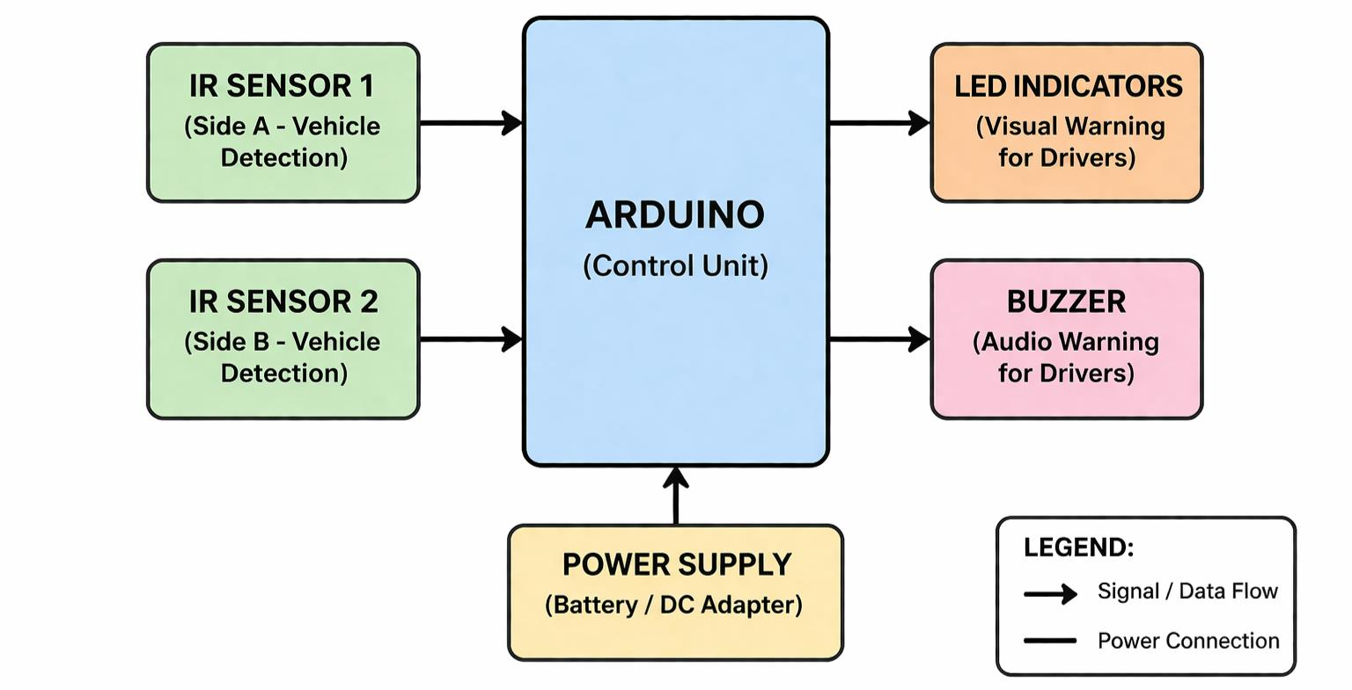
3.1 FEATURES OF PROPOSED SYSTEM
The proposed Accident Prevention system using IR sensors is designed to be a simple, reliable, and effective solution for improving road safety in hilly areas. The system stands out due to its low cost, ease of installation, and ability to function in harsh weather conditions commonly found in mountainous regions.
Key features of the proposed system are:
- Real-time Vehicle Detection: Uses IR sensors to instantly detect oncoming vehicles even in fog, rain, dust, or low-light conditions.
- Reliable Relay Operation: Employs electromagnetic relays to safely control warning devices without overloading the microcontroller.
- Weather-Resistant Design: Works effectively in adverse weather and requires minimal maintenance, suitable for harsh mountainous environments.
- Fully Automated Operation: Operates without any manual intervention and responds quickly to prevent head-on collisions on blind bends.
Overall, these features make the proposed system highly practical and efficient for enhancing safety on dangerous ghat sections, hairpin turns, and tourist routes in hilly areas. It provides an active safety solution where traditional passive methods often fail.
3.2 ADVANTAGES OF PROPOSED SYSTEM
The proposed Accident Prevention system using IR sensors offers several important advantages over traditional safety measures and other existing systems. It is specifically designed to address the challenges of hilly and mountainous roads by providing active and real-time warnings to drivers.
Key advantages of the proposed system are:
- Enhanced Road Safety: Provides instant alerts to drivers approaching from both directions, significantly reducing the risk of head-on collisions and accidents caused by poor visibility.
- Low Cost: Uses inexpensive and easily available components, making it highly affordable for widespread deployment on national highways and remote hill roads.
- Reliability in Harsh Weather: IR sensors work effectively in fog, rain, dust, and low-light conditions where traditional signs, mirrors, and camera systems often fail.
- Fully Automated Operation: Requires no manual intervention and responds quickly, giving drivers sufficient time to slow down or stop safely.
- Easy Installation and Maintenance: Simple design allows quick installation at critical locations with minimal infrastructure changes and low maintenance needs.
- Energy Efficient and Scalable: Can be powered by battery or solar panels and can be easily scaled to cover multiple curves and high-risk mountain sections.
Overall, the proposed system combines simplicity, reliability, and effectiveness, making it a valuable technology-driven approach to improve road safety in challenging hilly terrains

CHAPTER-4
SYSTEM DESIGN
he proposed system focuses on detecting vehicles at blind curves using IR sensor pairs placed on both sides of a hairpin turn. Each sensor unit consists of an IR emitter and receiver; when a vehicle interrupts the IR beam, the sensor generates a signal that is sent directly to a central microcontroller. The microcontroller processes this input to identify which side of the road currently has an approaching vehicle.
Instead of using a relay module, the system directly controls warning indicators through the microcontroller using suitable driver circuits such as transistors or MOSFETs. When a vehicle is detected on “Side A,” the microcontroller immediately activates a high-intensity LED indicator or a “Slow Down” warning display on “Side B.” This ensures that drivers approaching from the opposite direction receive a clear and immediate visual alert, even in areas where visibility is completely blocked by terrain or vegetation.
The elimination of the relay module improves the system by reducing mechanical components, increasing reliability, and lowering power consumption. Solid-state switching using transistors allows faster response times and minimizes wear and tear, making the system more suitable for long-term deployment in remote and harsh environments.
The system is designed to operate efficiently in off-grid locations by using solar panels and rechargeable batteries. This ensures continuous operation without dependency on external power sources. The microcontroller is programmed with a “clearance delay” logic, which keeps the warning signal active for a predefined time even after the vehicle passes the sensor. This prevents the signal from turning off too early and avoids confusion for oncoming drivers.
For enhanced safety, the system can also include a buzzer to provide audible alerts along with visual warnings. Additionally, it can be integrated with IoT or GSM modules to monitor traffic patterns and improve road safety management. By analyzing how frequently the sensors are triggered, authorities can identify high-risk zones and take preventive measures.
In emergency situations, such as when a vehicle remains stationary within the sensor range for an extended period, the system can detect this abnormal condition and automatically send an alert message to nearby emergency services using a GSM module. This feature ensures timely response and assistance, potentially saving lives.
Overall, by replacing the relay module with solid-state switching and maintaining intelligent detection and alert mechanisms, the system becomes more efficient, reliable, and better suited for real-world accident prevention in hilly and blind curve regions.
4.1 SOFTWARE REQUIREMENTS
The primary software requirement is an Integrated Development Environment (IDE), such as the Arduino IDE or PlatformIO. These tools are used to write, compile, and upload the control logic to the microcontroller. The software must be written in Embedded C or C++ to handle low-level hardware interactions and real-time processing efficiently.
The code must include a specific module for Signal Acquisition. This software component continuously polls the digital input pins connected to the IR sensors. It requires logic to distinguish between a momentary "noise" signal and a true vehicle detection, often using a small software debounce or a threshold check to ensure accuracy.
A core requirement is a Decision-Making Algorithm that determines the state of the relays. The software must implement conditional "If-Then" logic: if Sensor A is triggered, then Relay B must be activated.
The software requires a Non-Blocking Timing Mechanism (using functions like millis() instead of delay (). This allows the system to keep a warning light active for a specific duration—long enough for a car to clear the curve—while still being able to "listen" for new vehicles entering the sensor zone simultaneously.
Since these systems are often solar-powered, the software should include Power Optimization Routines. This involves putting the microcontroller into a "low-power sleep mode" during periods of inactivity and using "interrupts" to wake the system instantly when a sensor detects motion, significantly extending battery life.
During the deployment phase, the software must support Serial Communication Protocols. This allows developers to connect a laptop to the system and view a live data feed of sensor values and relay states. This requirement is essential for calibrating the IR sensitivity based on the specific width and lighting conditions of the mountain road.


4.2 HARDWARE REQUIREMENTS
The core of the system is a microcontroller, such as an Arduino Uno or ESP32. This acts as the central processing unit that receives signals from the sensors and executes the programmed logic to trigger the alerts. It must have sufficient digital I/O pins to accommodate multiple sensors and relay modules simultaneously.
High-sensitivity IR sensor pairs (transmitter and receiver) are required to detect vehicle presence. These sensors are placed at the entry and exit points of the curve. They work by emitting an infrared beam; when a vehicle passes, the beam is reflected or interrupted, changing the sensor's output signal from low to high.Relay modules are essential for switching the high-power warning components. Since the microcontroller operates at low voltage (3.3V or 5V), it cannot directly power large signal lights.
To provide visible alerts to drivers, the system requires High-Intensity LEDs or LED matrix panels. These are typically red or amber and must be bright enough to be seen in broad daylight, heavy fog, or torrential rain, which are common conditions in high-altitude hilly regions.A stable power source is critical. This usually involves a 12V Lead-Acid battery or a Lithium-ion pack paired with a Solar Panel for remote recharging. Additionally, a voltage regulator (like the LM7805) is needed to step down the battery voltage to a steady 5V for the delicate electronic components.
Since the hardware is deployed outdoors, IP65-rated weatherproof casings are required to protect the circuitry from moisture, dust, and temperature fluctuations. Robust mounting poles or brackets are also necessary to ensure the IR sensors remain perfectly aligned despite wind or vibrations.
4 COMPONENTS USED IN PROPOSED SYSTEM
1. Arduino Uno (Microcontroller)
The blue board mounted in the center is an Arduino Uno. It acts as the primary control unit, programmed to read the IR sensor inputs and drive the traffic lights, buzzer, and LCD.
2. IR Sensor Modules (Detection)
You have two IR Sensor Modules (the small blue rectangular boards on the left and right edges). These are used to detect vehicles. Each has an IR transmitter (clear LED) and a receiver (black LED). The blue potentiometer (the small screw) on these modules allows you to calibrate the detection distance.
3. Traffic Light LED Modules
Instead of single LEDs, your setup uses two Mini Traffic Light Modules. These boards consist of three LEDs (Red, Yellow, and Green) pre-arranged in a vertical column. These are mounted at the "top" of your board to represent the signals at two different ends of a hilly road or intersection.
4. 16x2 LCD Display with I2C/Parallel Interface
The large green component at the bottom right is a 16x2 Character LCD. This is used to provide status updates to the user, such as "Road Clear," "Vehicle Detected," or "Slow Down." It allows the system to communicate complex information that a simple LED cannot.
5. Piezo Buzzer
The small black circular component in the center of the board is a Piezo Buzzer. This provides the auditory warning. When an IR sensor is triggered, the Arduino sends a signal here to create a beeping sound, alerting drivers or pedestrians who might not be looking at the lights.
6. Power Supply Circuitry (Voltage Regulator)
On the bottom left of the green base board, there is a DC Power Jack and a Voltage Regulator (the black component with three legs and a metal heat sink). This circuitry takes an external power input (like a 12V adapter) and stabilizes it to the 5V needed to run the Arduino and the sensors without damaging them.
4.4.1 ARDUINO IDE
Arduino Integrated Development Environment (IDE) is a powerful open-source software platform used for writing, compiling, and uploading programs to microcontroller-based hardware systems. It is widely used in embedded system development and automation projects due to its user-friendly interface and compatibility with a variety of microcontrollers.
Features and Functions
Arduino IDE provides a simple yet effective development framework, allowing users to code in C/C++ and interface with numerous hardware components. It supports real-time programming, enabling developers to write and execute code seamlessly. Some key features include:
- Code Editor – Arduino IDE includes a structured editor with syntax highlighting, making coding easier and more readable.
- Debugger and Compiler – Built-in debugging and compiling tools ensure smooth execution of programs without external dependencies.
- Serial Monitor – This feature allows users to track sensor data, diagnose errors, and test real-time outputs from connected devices.
- Library Management – The IDE supports a vast library database for connecting ultrasonic sensors, servometers, laser modules, and wireless communication units like ESP8266.
- Cross-Platform Compatibility – It runs on Windows, Mac, and Linux, providing flexibility for developers to work on different systems.
- Vast Community Support – A large open-source community contributes to regular updates, troubleshooting guides, and code repositories, making implementation easier.
- Integration of Libraries – Supports various libraries that enable efficient interfacing with sensors, wireless communication modules, and display units.
- Real-Time Testing – The serial monitor feature allows debugging and testing programs directly with hardware components.

Installation and Configuration
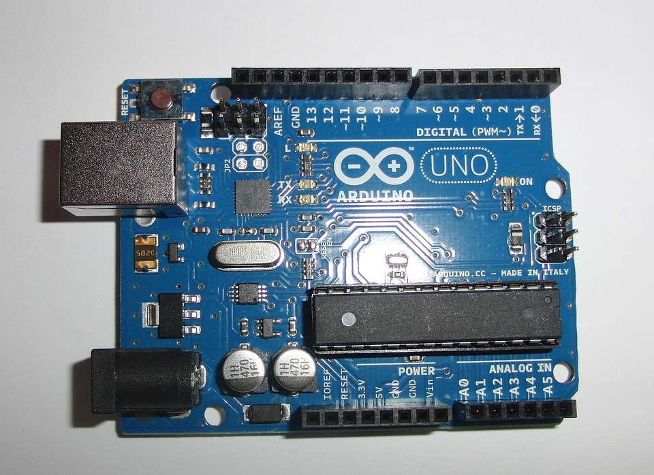
Setting up Arduino IDE is straightforward. Users can download it from the official Arduino website, install it on their computer, and configure it by selecting the appropriate board and port settings. The IDE is compatible with various microcontrollers, including Arduino Uno, Mega, and ESP8266, making it adaptable.
Fig. 4.4.1 Arduino IDE

4.4.2 IR SENSOR
An IR (Infrared) Sensor is an electronic device that detects or measures infrared radiation in its surrounding environment. It typically consists of an IR LED that emits invisible infrared light and a Photodiode (receiver) that identifies the intensity of the light reflected back from an object. When a vehicle or person enters the sensor's path, the emitted light bounces off their surface and is captured by the receiver, triggering an electrical signal. Because they are affordable, respond instantly, and consume very little power, they are widely used in proximity detection, automated lighting, and obstacle avoidance systems for robotics and road safety.
Working Principle
An IR (Infrared) Sensor is a versatile electronic device that detects the presence or distance of an object by emitting and receiving infrared radiation. It consists of an IR LED that sends out an invisible light beam and a Photodiode that acts as a receiver. When an object, such as a vehicle on a mountain road, moves into the sensor's path, the infrared light reflects off its surface and back into the photodiode. This reflection creates an electrical signal that a microcontroller like an Arduino can process instantly to trigger safety alarms or traffic lights, making it a highly efficient and low-cost solution for real-time motion detection.
Role in Accident Prevention in Hilly Areas Using IR Sensors and Relays
When a vehicle passes the first sensor, it immediately sends a signal to the microcontroller, which then activates a relay (or direct LED output) to trigger warning lights on the opposite side of the bend. This informs the oncoming driver that the narrow path is currently occupied, allowing them to slow down or stop in a safe spot. By automating this communication between two hidden sides of a hill, the system effectively eliminates the element of surprise, which is the leading cause of head-on collisions in mountainous regions.
Advantages of Ultrasonic Sensors
* Real-Time Collision Prevention: The system identifies vehicles at blind spots instantly, providing immediate visual and auditory warnings that allow drivers to react before they even see the oncoming car.
* Low Power Consumption: Because IR sensors and microcontrollers require very little voltage, the system is highly energy-efficient and can run for extended periods on small batteries or solar setups.
* Cost-Effective Implementation: Compared to expensive radar or LiDAR systems, IR sensors and Arduino-based components are affordable, making it feasible to install multiple units along long stretches of mountain roads.
* Automated 24/7 Monitoring: The system operates without human intervention, ensuring constant surveillance of dangerous curves regardless of the time of day or the presence of traffic police.
Challenges and Limitations
* Sensitivity to Ambient Light: IR sensors can be highly sensitive to natural sunlight, which contains a broad spectrum of infrared radiation. In bright daylight, the sensor may receive "false triggers" from the sun, causing the traffic lights to activate even when no vehicle is present.
* Weather Interference: Environmental factors like heavy rain, dense fog, or falling snow—all common in mountainous regions—can scatter or block the infrared beam. This significantly reduces the detection range and reliability, as the sensor might fail to "see" a vehicle through the moisture or debris.
* Short Detection Range: Standard IR modules, such as those used in many prototypes, typically have a very limited range (often under 1 meter). For a real-world hilly road, this is a major limitation, as the sensors would need to be replaced with industrial-grade, long-range laser or IR beams to detect wide vehicles from a distance.

Future Enhancements
A future enhancement for this accident prevention system involves integrating IoT-enabled LiDAR and AI-based computer vision to create a more robust detection network. While standard IR sensors struggle with sunlight and fog, LiDAR uses laser pulses to provide accurate 3D mapping in all weather conditions, while AI cameras can distinguish between actual vehicles and false triggers like falling rocks or stray animals. Furthermore, adding V2X (Vehicle-to-Everything) communication would allow the system to transmit warnings directly to a driver’s dashboard or smartphone, ensuring that the alert is received even if the roadside LED signals are obscured by heavy rain or sharp mountain

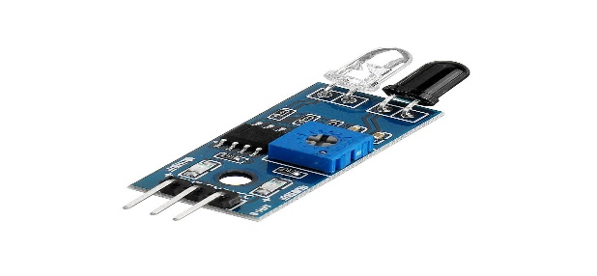
Fig. 4.4.2 IR SENSOR
4.4.3 LCD DISPLAY
A 16x2 LCD (Liquid Crystal Display) is an alphanumeric display module that can show up to 32 characters across two rows. In an accident prevention system, it acts as the primary communication interface, translating raw sensor data into readable text for drivers or technicians. By using liquid crystals to modulate light, it displays real-time status updates such as "Road Clear," "Vehicle Detected," or "Slow Down," providing a much higher level of detail than simple LED lights. Its low power consumption and ability to interface easily with microcontrollers like the Arduino via I2C or parallel pins make it an essential component for monitoring system health and traffic flow in remote hilly regions.
Working Principle
The working principle of a 16x2 LCD is based on the light-modulating properties of liquid crystals, which do not emit light directly but instead use a backlight or reflector to produce images. The display consists of a layer of liquid crystal molecules aligned between two transparent electrodes and polarizing filters; when the Arduino sends an electrical signal to specific pixels, it changes the orientation of these molecules to block or allow light to pass through. This process creates the visible alphanumeric characters on the screen, organized into a grid of 5x8 pixel blocks. By controlling these pixels through a specialized driver chip (like the HD44780), the system can instantly translate complex digital data into readable text for the user.
Role in Accident Prevention in Hilly Areas Using IR Sensors and Relays
The role of the 16x2 LCD in an accident prevention system is to act as the primary visual communication interface between the hardware and the road users or maintenance staff. While LEDs provide a simple binary signal (stop or go), the LCD offers detailed, real-time feedback by displaying specific text messages such as "Vehicle Approaching," "Path Clear," or "System Standby." In hilly areas, this added layer of information helps reduce driver anxiety and confusion at blind curves. Furthermore, the display serves a critical diagnostic role; it can show system health data, battery voltage, or sensor calibration levels, allowing technicians to quickly identify and fix faults in remote locations without needing external testing equipment.
Advantages of Servometers
Clear Communication: Provides detailed text instructions rather than just simple colored lights.
​Low Power Use: Extremely energy-efficient, making it ideal for solar-powered roadside units.
​Real-Time Diagnostics: Displays technical data like battery levels or sensor status for easy troubleshooting.
​High Readability: Offers a professional, easy-to-read interface that functions well in various lighting conditions.
Challenges and Limitations
* Temperature Sensitivity: In the extreme cold of hilly regions, the liquid crystals can freeze or become sluggish, causing the display to lag or fail.
* Poor Distance Visibility: The small 16x2 screen size makes it difficult for drivers to read messages from a distance or while moving at high speeds.
* Fragility: The glass components are susceptible to cracking from the heavy vibrations of passing trucks or falling rocks.
* Sunlight Washout: Without a high-contrast backlight, the text can become nearly invisible under direct, intense mountain sunlight.
Future Enhancements
A significant future enhancement for the display system involves transitioning to High-Brightness OLED or LED Matrix panels equipped with I2C communication modules. These upgrades would solve the current limitations by offering superior visibility in direct sunlight and reducing the complex wiring from sixteen pins to just four, which minimizes the risk of failure from road vibrations. Furthermore, integrating Multi-language Scrolling and IoT-based remote diagnostics would allow the display to provide safety warnings in local dialects while simultaneously reporting system health to a central cloud server for easier maintenance in remote hilly regions.
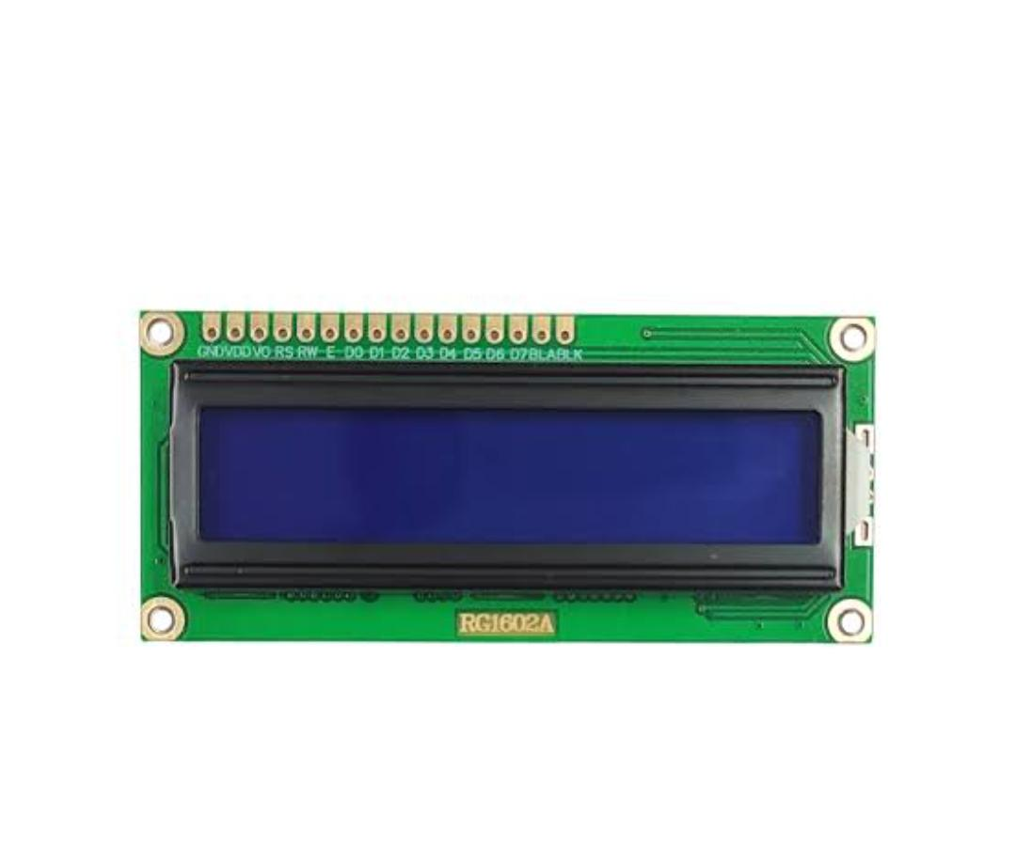
Fig. 4.4.3 LCD DISPLAY
4.4.4 LED SIGNALS
LED signals in an accident prevention system serve as the immediate visual warning for drivers, converting electrical signals from the microcontroller into high-visibility light. Unlike traditional incandescent bulbs, LEDs (Light Emitting Diodes) trigger instantly, which is crucial for providing split-second warnings at dangerous mountain curves. Typically arranged in a "Traffic Light" configuration (Red for "Stop/Wait" and Green for "Go"), they provide a universal language that drivers can understand from a distance, even in low-visibility conditions like dusk or light rain.
Working Principle
The working principle of LED signals is based on electroluminescence, where light is emitted when an electric current passes through a semiconductor material. In this safety system, when the IR sensor detects a vehicle, the microcontroller sends a signal to a relay or transistor that completes the circuit for the LED. This causes electrons to recombine with holes within the diode, releasing energy in the form of photons. This process is nearly instantaneous and produces a highly directional, monochromatic light that can penetrate through hazy conditions, providing an immediate visual alert to oncoming drivers
Role in Accident Prevention in Hilly Areas Using IR Sensors and Relays
The role of LED signals is to serve as the critical, high-speed visual alert that communicates road status to drivers in real-time. Positioned prominently before blind curves, they act as the "eyes" for the motorist, indicating whether the hidden section of the road is occupied or clear. By flashing red when a vehicle is detected by sensors on the opposite side, they provide the necessary lead time for drivers to slow down or yield, effectively neutralizing the danger of blind-spot collisions in rugged terrai
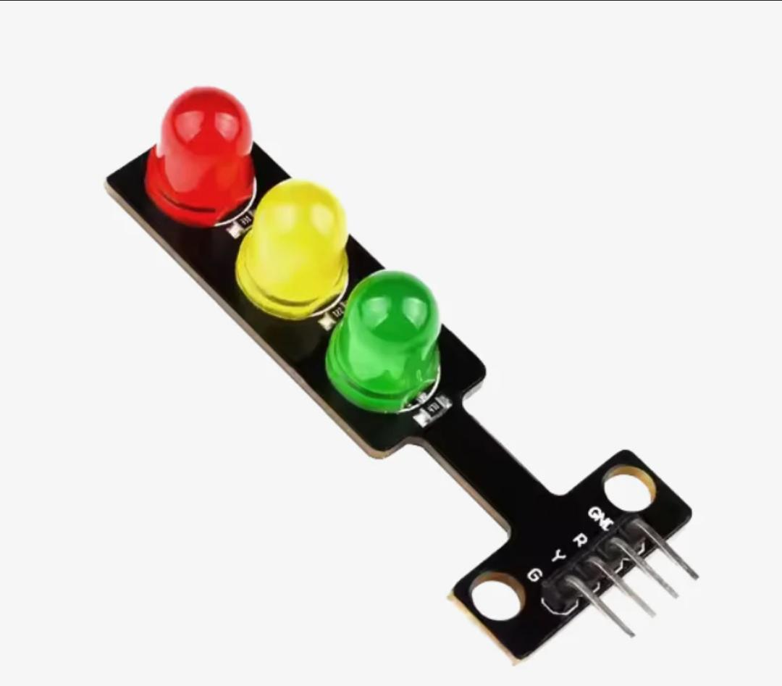
Fig.4.4.4 Laser
Advantages of LED SIGNALS
* Instant Response: LEDs reach full brightness in nanoseconds, providing the immediate warning necessary for high-speed mountain traffic where every split second counts.
* High Visibility: They produce intense, directional light that remains visible from a distance even in challenging conditions like dusk, fog, or light rain.
4.4.5 BUZZER
A buzzer is an essential component in the missile detection system, serving as an alert mechanism that provides immediate auditory feedback upon detecting an incoming object. It enhances system responsiveness by notifying users of potential threats, ensuring timely action.
Working Principle
A buzzer operates by converting electrical signals into sound waves. When an object is detected, the system triggers the buzzer, causing it to emit a loud alarm. The frequency and duration of the sound can be adjusted based on detection parameters, allowing for different alert levels depending on the object's proximity and movement speed.
Role in Missile Detection System
The buzzer plays a crucial role in enhancing situational awareness. Upon detecting a missile or moving object, the system activates the buzzer to alert users. This immediate notification ensures that necessary defensive measures can be taken promptly. The buzzer works in coordination with ultrasonic sensors, servometers, and laser modules to provide a comprehensive detection and response system.
Advantages of Buzzers
- Immediate alert mechanism – Provides instant feedback upon detection.
- Customizable sound patterns – Can be programmed to emit different tones based on threat levels.
- Low power consumption – Operates efficiently without excessive energy usage.
- Compact and lightweight – Easily integrated into missile detection systems.

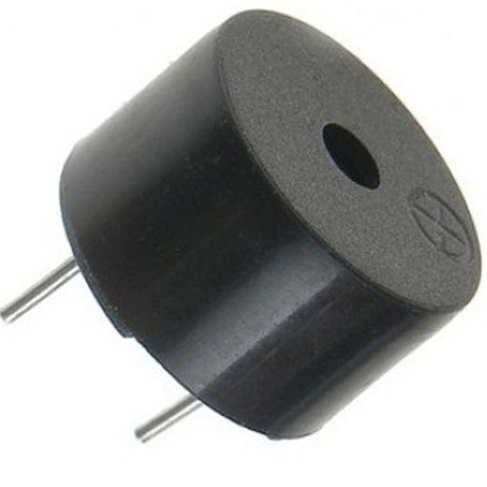

Fig. 4.4.5 Buzzer
Challenges and Limitations
- Limited range – Buzzers may not be effective in large areas without additional amplification.
- Environmental interference – Background noise can reduce the effectiveness of alerts.
- Durability concerns – Continuous operation may lead to wear and tear over time.
Future Enhancements
Future improvements could involve integrating buzzers with visual alert systems, such as LED indicators, to enhance notification efficiency. AI-based threat assessment could also be used to modify buzzer activation patterns based on object classification and movement analysis.

CHAPTER-5
SYSTEM ARCHITECTURE
Accident prevention in hilly areas is a major challenge due to sharp curves, narrow roads, and low visibility. Drivers often cannot see vehicles coming from the opposite direction, which increases the risk of collisions. To overcome this problem, an intelligent system using Infrared (IR) sensors can be implemented to detect vehicles and provide timely warnings.
The proposed system mainly consists of IR sensors, a microcontroller (such as Arduino), an alert system (LEDs and buzzer), and a power supply. IR sensors are installed on both sides of a blind curve to detect the presence of vehicles. These sensors continuously monitor the road and send signals whenever an object (vehicle) is detected.
The microcontroller acts as the central processing unit of the system. It receives input signals from the IR sensors and processes the data to determine whether vehicles are approaching from both sides simultaneously. Based on this analysis, it decides whether to trigger warning signals or indicate that the road is safe.
The alert system includes visual and audio indicators such as LEDs and a buzzer. When a vehicle is detected on the opposite side, the system activates a red LED and a buzzer to warn the driver.
The system is powered by a reliable power supply, which can be a battery or a solar panel for remote hilly areas. Using solar energy makes the system more efficient and suitable for locations where electricity supply is limited. The system is designed to operate continuously with minimal maintenance.
Overall, this IR sensor-based accident prevention system is a simple, cost-effective, and efficient solution for improving road safety in hilly areas. It reduces the chances of head-on collisions by providing early warnings to drivers. With proper installation and maintenance, this system can significantly enhance safety on dangerous hill roads.

5.1 BLOCK DIAGRAM

- Buzzer – Provides an audible alert when an object is detected, notifying users of potential threats.
- IR Sensors: Detect vehicles on both sides using infrared signals.
- Microcontroller: Processes inputs and controls the entire system.
- Traffic Light LEDs: Indicate stop/go signals to prevent accidents.
- LCD Display: Shows status messages for drivers.
- Power Supply: Converts and regulates power for the circuit.

5.2 CIRCUIT DIAGRAM
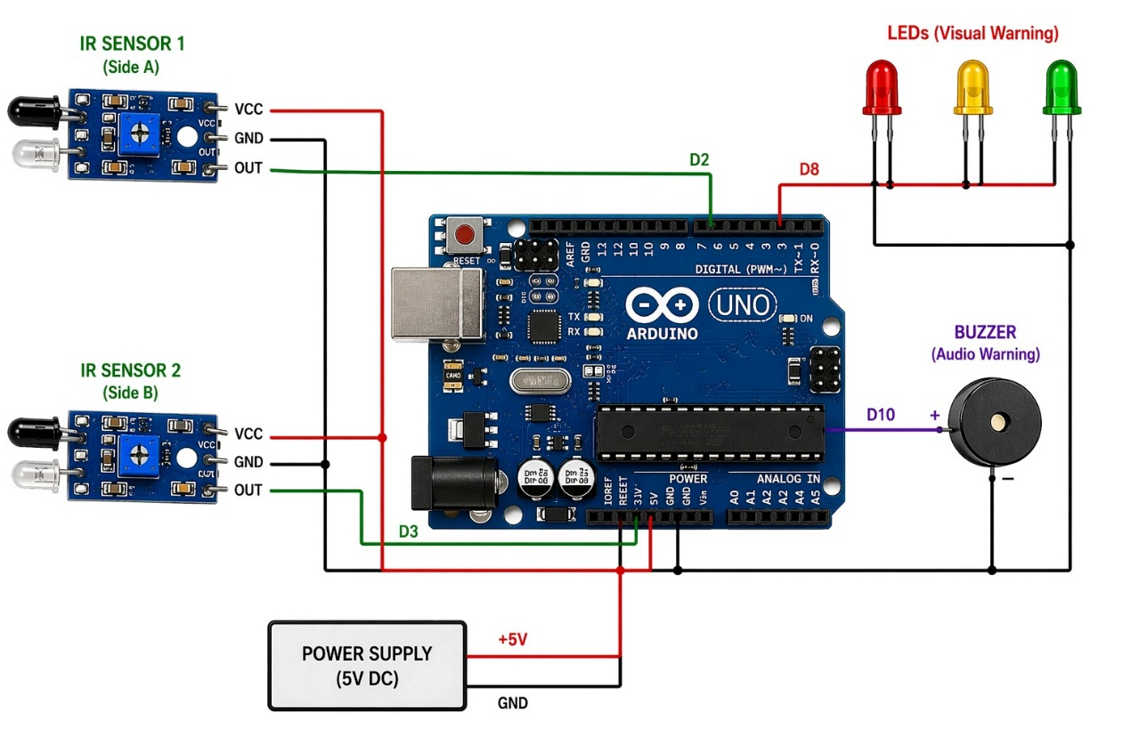
Fig. 5.2 Circuit diagram
The proposed system is designed to prevent road accidents in hilly areas and blind curves where visibility is very low and drivers cannot see vehicles approaching from the opposite side. In such regions, lack of proper traffic control often leads to collisions.
The system uses two IR sensors, placed on either side of the road. These sensors work on the principle of infrared reflection, where an IR transmitter emits rays and the receiver detects the reflected signal when a vehicle passes in front of it. When a vehicle is detected, the sensor sends a signal to the microcontroller, which acts as the brain of the system.
The microcontroller continuously monitors inputs from both sensors and processes them based on programmed logic. If a vehicle is detected on one side only, the system allows that side to move by turning the green LED ON, indicating a safe passage. At the same time, the opposite side is given a red signal, instructing vehicles to stop. This ensures smooth and controlled traffic flow.

CHAPTER-6
METHODOLOGY
Implementing an accident prevention system in mountainous terrain requires a blend of hardware precision and strategic placement. Hilly areas are notorious for "blind curves" where visibility is obstructed by the natural landscape, making real-time detection essential.
The core methodology relies on a dual-node detection system placed at both ends of a sharp curve or hairpin bend. By using Infrared (IR) sensors, the system can detect the presence of a vehicle before it is visible to oncoming traffic. This "anticipatory alert" mechanism provides drivers with the extra seconds needed to adjust their speed or stay within their lane, effectively neutralizing the danger of the blind spot.
At the heart of the system is the IR sensor pair, consisting of an IR transmitter and a receiver. The transmitter emits a continuous beam of infrared light; when a vehicle passes, it reflects this light back to the receiver. This change in the sensor's output state acts as a digital trigger, signalling the presence of an object within the sensor's range.
Placement is critical for minimizing false positives and ensuring maximum reaction time. Sensors are typically installed at a specific height—usually 2 to 3 feet above the road surface—to ensure they detect the body of a car or truck rather than smaller animals or debris. They are positioned several meters before the curve starts, allowing the signal to travel to the opposite side of the bend well before the vehicles meet.
The data from the sensors is fed into a microcontroller, such as an Arduino or Raspberry Pi. The controller is programmed with logic that interprets the sensor inputs. For instance, if Sensor A (on the uphill side) is triggered, the controller immediately activates a visual warning on the downhill side. This processing happens in milliseconds, ensuring that the warning is virtually instantaneous.
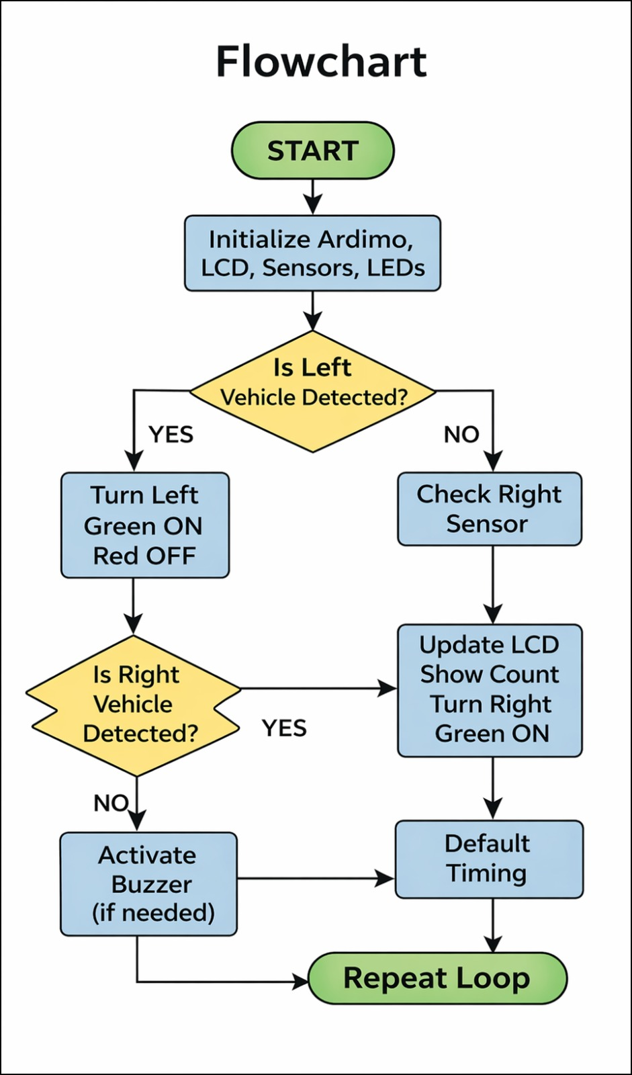Fig. 6.1 Flow Chart

CHAPTER-7
IMPLEMENTATION
Expanding the implementation of an IR-based accident prevention system for hilly terrain requires a deep dive into the integration of hardware, software logic, and environmental engineering.
The first step in implementation is a thorough survey of the specific "black spot" or blind curve. Engineers must measure the curvature radius and the average speed of vehicles to determine the "Reaction Buffer Zone."
Selecting industrial-grade components is vital for reliability. While hobbyist sensors work for prototypes, a field implementation requires long-range IR modules with built-in ambient light filters. The code must be written to handle complex scenarios, such as two vehicles entering the curve from opposite sides at the same time. The logic uses a "state machine" approach: if Sensor A is triggered, it locks the "Green" state for Side A and triggers "Red" for Side B.
Since mountain roads are often far from power grids, a standalone solar power system is installed. This includes a 12V or 24V solar panel, a charge controller to prevent overcharging, and a lead-acid or Lithium-ion battery bank. The power consumption of the IR sensors and LEDs is calculated to ensure the system can run for at least three days without sunlight.
Environmental factors like falling leaves, heavy rain, or small animals could potentially trigger the system. To prevent this, the microcontroller logic is calibrated to require a "Minimum Trigger Duration."
In many remote areas, equipment can be subject to theft or vandalism. The implementation includes securing the solar panels high up on poles and using anti-theft bolts for the sensor enclosures. The battery boxes are often buried underground or encased in reinforced concrete to prevent tampering.
Once all components are installed, the "Live Test" phase begins. Test vehicles are driven through the curve at varying speeds—from 20 km/h to 60 km/h—to verify the timing of the warning lights.
A technological solution is only effective if drivers understand it. Alongside the lights, static signs are placed 100 meters before the system, explaining: "Automatic Vehicle Detection Ahead - Observe Lights." This prepares the driver to look for the IR-triggered signals.
The final stage involves evaluating the success of the pilot installation. If accident rates decrease at the target curve, the methodology can be scaled to an entire mountain pass. Multiple units can eventually be linked to a central monitoring station, creating a "Smart Hill Road" network that provides real-time safety data to highway patrols.

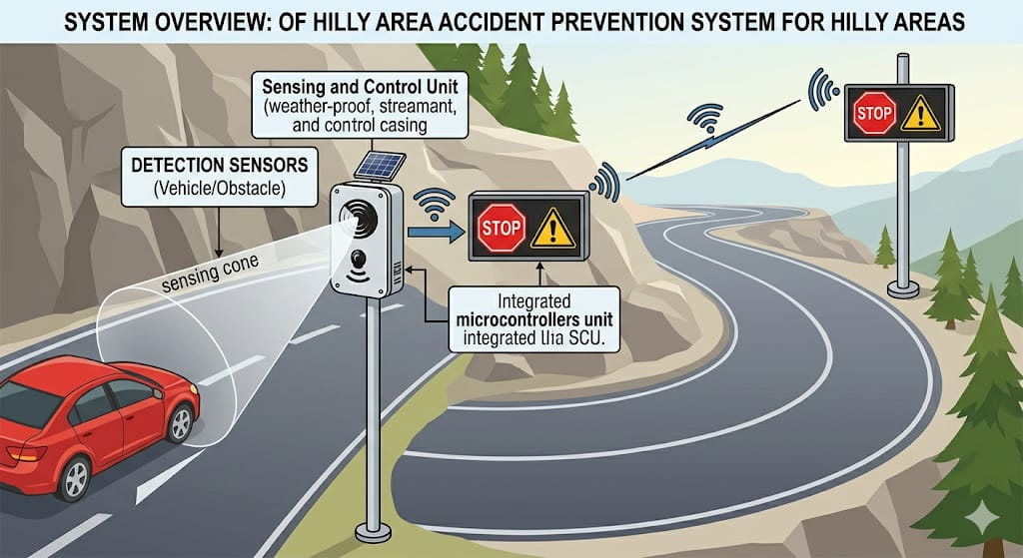

7.1 System overview

7.1 SOURCE CODE
Arduino Code Implementation
#include <LiquidCrystal.h>
const int rs = 13, en = 12, d4 = 11, d5 = 10, d6 = 9, d7 = 8;
LiquidCrystal lcd(rs, en, d4, d5, d6, d7);
int irl=7;
int irr=6;
int rl=5;
int gl=4;
int rr=3;
int gr=2;
int buzzer=A0;
void setup()
{
lcd.begin(16, 2);
pinMode(irl,INPUT);
pinMode(irr,INPUT);
pinMode(rl,OUTPUT);
pinMode(gl,OUTPUT);
pinMode(rr,OUTPUT);
pinMode(gr,OUTPUT);
pinMode(buzzer,OUTPUT);
digitalWrite(buzzer,HIGH);
digitalWrite(rl,LOW);
digitalWrite(gl,LOW);
digitalWrite(rr,LOW);
digitalWrite(gr,LOW);
Serial.begin(9600);
}

void loop()
{
int irlval=digitalRead(irl);
int irrval=digitalRead(irr);
if(irlval==LOW)
{
lcd.setCursor(0,0);
lcd.print("LEFT:SIDE:BUSY");
digitalWrite(rr,HIGH);
digitalWrite(gr,LOW);
digitalWrite(buzzer,LOW);delay(100);
digitalWrite(buzzer,HIGH);
delay(10);
}
if(irlval==HIGH)
{
digitalWrite(rr,LOW);digitalWrite(gr,HIGH);
lcd.setCursor(0,0);lcd.print("LEFT:SIDE:FREE");
}

if(irrval==LOW)
{
lcd.setCursor(0,1);lcd.print("RIGHT:SIDE:BUSY");
digitalWrite(rl,HIGH);digitalWrite(gl,LOW);
digitalWrite(buzzer,LOW);delay(100);digitalWrite(buzzer,HIGH);delay(10);
}
if(irrval==HIGH)
{
digitalWrite(rl,LOW);digitalWrite(gl,HIGH);
lcd.setCursor(0,1);lcd.print("RIGHT:SIDE:FREE");
}

CHAPTER-8
RESULTS
The implemented system for Accident Prevention in Hilly Areas using IR Sensors was successfully designed and tested. The circuit was able to detect vehicles on both sides of a simulated hilly road using IR sensors and respond accordingly through LEDs, buzzer, and LCD display.
During testing, when a vehicle was detected on only one side, the system provided a green signal for that side and a red signal for the opposite side, allowing safe movement. When vehicles were detected on both sides simultaneously, the system correctly identified a potential collision condition and activated the buzzer alert along with red signals on both sides, ensuring that both vehicles stop.
The LCD display functioned properly, showing real-time messages such as “Vehicle Detected,” “STOP,” and “GO”, which enhanced user understanding. The response time of the system was quick and consistent, making it suitable for real-time applications.
Overall, the project achieved its objective of providing a low-cost, automated, and efficient accident prevention system, making it a practical solution for improving road safety. The radar interface continued scanning without highlighting any detection, demonstrating the range filter worked as intended.

TEST CASE-1:
No vehicles on both sides:
- Green lights ON (both sides)
- Red lights OFF
- Buzzer OFF
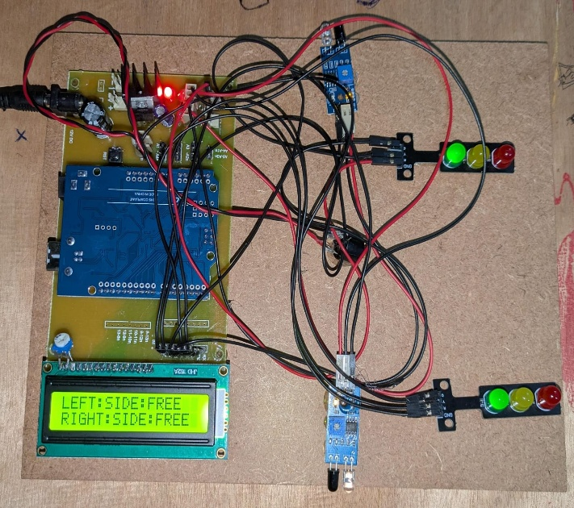

TEST CASE-02: Vehicle on RIGHT side only:
- Right side:
  - Red light ON
  - Green light OFF
- Left side:
  - Green light ON
  - Red light OFF
- Buzzer beeps
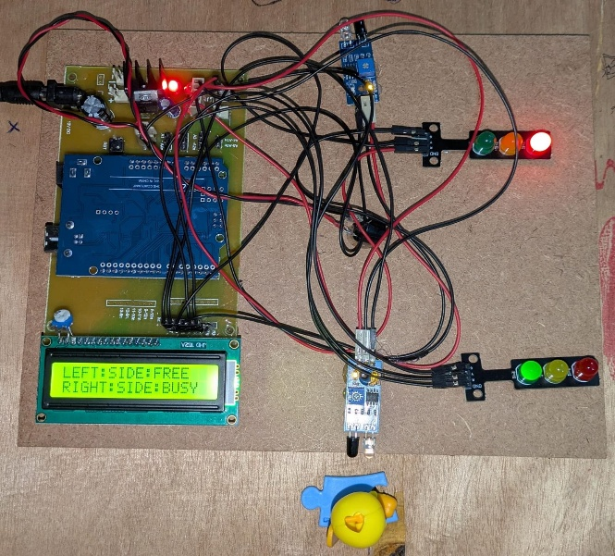
TEST CASE-03: Vehicle on LEFT side only:
- Left side:
  - Red light ON
  - Green light OFF
- Right side:
  - Green light ON
  - Red light OFF
- Buzzer beeps
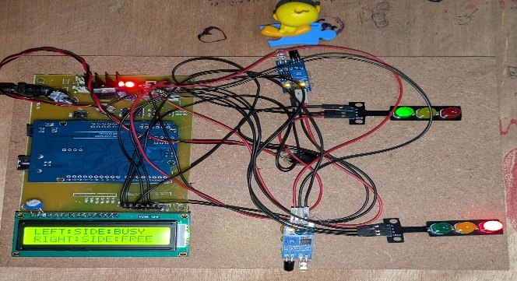
TEST CASE-04: Vehicles on BOTH sides
- Both Red lights ON
- Both Green lights OFF
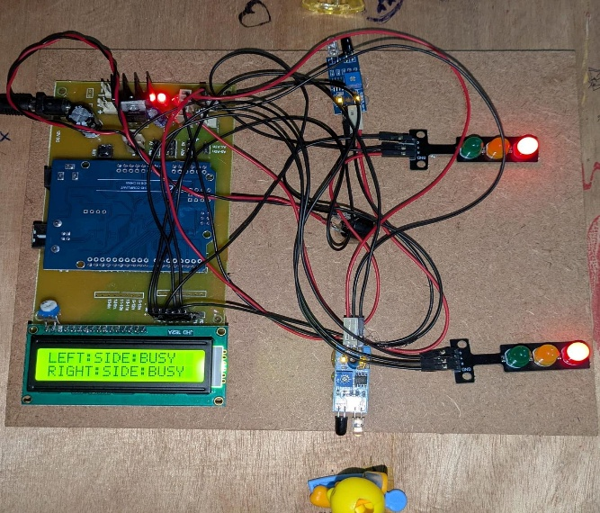
8.1 Test Results of Accident prevention in hilly areas using IR Sensors
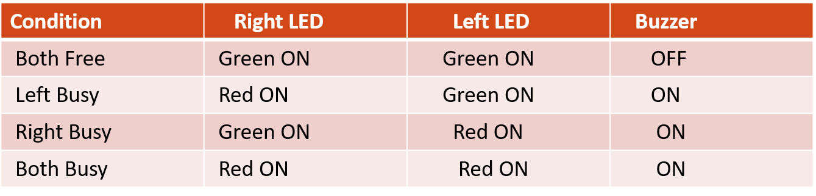

Conclusions
The project titled “Accident Prevention in Hilly Areas using IR Sensors” has been successfully designed, developed, and tested, demonstrating an effective solution to reduce road accidents in regions with poor visibility such as hilly terrains and blind curves.
The system utilizes infrared (IR) sensors to detect the presence of vehicles on both sides of the road. These sensors operate on the principle of reflection of infrared rays, ensuring reliable detection. The signals generated by the sensors are processed by a microcontroller, which acts as the central decision-making unit. Based on the inputs received, the controller executes programmed logic to control the outputs such as traffic LEDs, buzzer, and LCD display.
The inclusion of an LCD display enhances the usability of the system by providing clear and real-time messages such as “STOP”, “GO”, and “Vehicle Detected.” This feature helps drivers understand the system status easily and react accordingly. Additionally, the power supply unit, consisting of a rectifier and voltage regulator, ensures a stable and uninterrupted supply of power to all components, contributing to the reliability of the system.
The project also highlights several advantages, including low cost, simplicity, ease of implementation, and real-time response. It can be easily installed in accident-prone areas without requiring complex infrastructure. However, certain limitations such as sensitivity of IR sensors to environmental conditions (like dust, fog, or rain) and limited detection range have been identified. These limitations can be addressed in future enhancements by incorporating advanced sensors such as ultrasonic or radar-based systems.
In conclusion, this project successfully demonstrates how embedded systems and sensor technology can be effectively utilized to improve road safety. It provides a practical, efficient, and scalable solution for accident prevention in hilly areas. With further advancements and real-world implementation, this system has the potential to significantly reduce accidents and save lives, making roads safer for everyone.

Future Scope
The project “Accident Prevention in Hilly Areas using IR Sensors” provides a basic and effective solution for improving road safety; however, there is significant scope for further enhancement and real-world implementation. With advancements in technology, this system can be upgraded to achieve higher accuracy, reliability, and wider applicability.
One of the major improvements can be the replacement of IR sensors with advanced sensing technologies such as ultrasonic sensors, radar sensors, or LiDAR systems. These sensors offer better accuracy and are less affected by environmental conditions like fog, rain, dust, or sunlight, which can impact IR sensor performance.
Another important enhancement is the integration of wireless communication technologies such as IoT (Internet of Things), GSM, or RF modules. By enabling communication between both sides of the hill, the system can share real-time vehicle data, improving synchronization and decision-making. Additionally, alerts can be sent to a centralized monitoring system or even to drivers via mobile applications.
The system can also be connected to smart city infrastructure, where data collected from multiple such installations can be analyzed for traffic patterns and accident-prone zones. This data can help authorities take preventive measures and improve road planning.
Another future direction is the development of a mobile application or in-vehicle alert system, where drivers receive notifications directly on their smartphones or vehicle dashboards. This would enhance awareness and allow drivers to respond more quickly.
Moreover, the system can be scaled and adapted for other applications such as railway crossings, parking management systems, and highway traffic control, making it a versatile solution beyond hilly areas.
In conclusion, the proposed system has a wide scope for enhancement by integrating modern technologies like IoT, AI, and renewable energy. With these improvements, it can evolve into a highly intelligent, fully automated, and widely deployable safety system, contributing significantly to the reduction of road accidents and the development of smarter transportation systems.
Sustainable Development Goals (SDGs)
Project: Accident Prevention System in Hilly Areas using IR Sensors
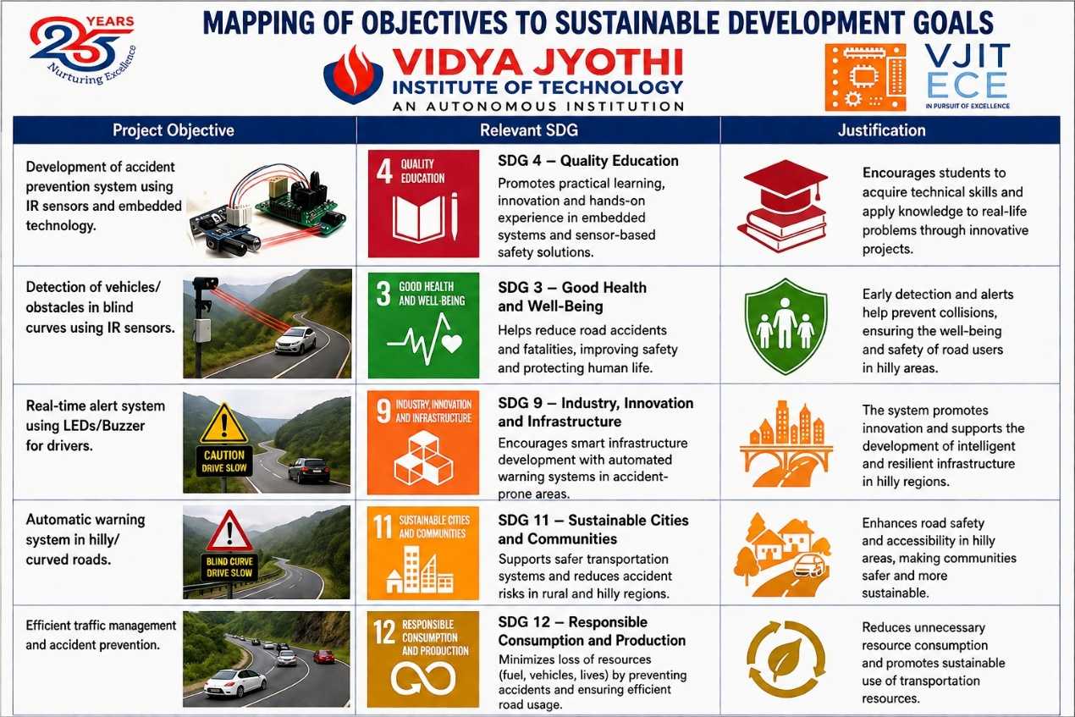

REFERENCES
[1] J. Satheesh Kumar et al., "Accident Prevention Using IR Sensors,"
International Journal of Novel Research and Development (IJNRD), 2023. https://ijnrd.org/papers/IJNRD2303128.pdf
[2] Swatika Srivastava et al., "IR Employed Arduino Based Accident-Avoidance in HillyAreas,".https://www.ijraset.com/research-paper/ir-employed-arduino-based-accident-avoidance-hilly-areas
[3] K. Sowjanya et al., "Accident Prevention in Hilly Areas Using IR Sensors and Relays,"IRJMETS, 2025.https://www.irjmets.com/upload_newfiles/irjmets70700069516/paper_file/irjmets70700069516.pdf
[4] M. Saila Bhanu et al., "Hilly Area Accident Prevention System Based on Infrared Sensors,"International Journal of Engineering Research Science & Technology (IJERST), 2025. https://ijerst.org/index.php/ijerst/article/view/695
[5] M. Siva Kumar et al., "System for Preventing Accidents in Deadly and Hilly Areas," https://ijnrd.org/viewpaperforall.php?paper=IJNRD2307063
[6] T.G. Tejaswini et al., "Smart Accident Prevention System for Curved Hill Roads Using IR Sensors,"
[7] Rupesh Bhise et al., "Accident Prevention on Hilly Road by Using Arduino and IR Sensor,"IJMRSET, 2024. https://www.ijmrset.com/upload/62_Accident.pdf
[8] Bhumika R et al., "Accident Prevention and Road Safety in Hilly Region using IoT Module,"International Journal of Engineering Research & Technology (IJERT), 2021.https://www.ijert.org/accident-prevention-and-road-safety-in-hilly-region
[9] Anand M G et al., "Sensor Based Accident Prevention System in Curving Roads,"
IJARIIE, 2019.https://ijariie.com/FormDetails.aspx?MenuScriptId=148970
[10] Aishwarya et al., "Automatic Fatality Prevention and Emergency Aid System,"
International Engineering Research Journal (IERJ), 2023.
https://ierj.in/journal/index.php/ierj/article/view/3965

